Date | Invoice#
Customer# | Project#
Customer PO# | Currency Used
Country of Origin | B/L / AWB No
Final Destination | Export Route/Carrier
Terms of Sale | Ship Via
Terms of Freight | Number of Packages
Special Shipping/Handling Instructions

Shipper/Exporter Wycliffe Associates
11450 Translation Way, Orlando FL 32832 P: +1 (407) 852-3800
www.wyclieassociates.org
Customer

Intermediate Consignee

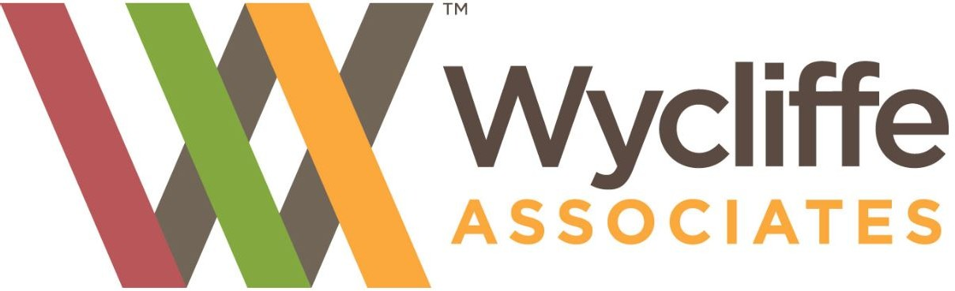

These goods have been purchased used in the United States and are for free distribution, having no commercial value and are not for resale. They are a donation to a charitable organization. Contact customer upon arrival.
 | QTY |  | Part# |  | Item Description |  | Unit Cost | Total Cost
 |  |  |  |  |  | Total Order Value :

